Boss Stats and Phases

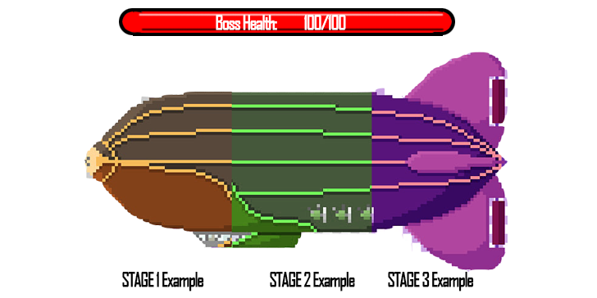

**Phase 1 20hp - 15hp**

Close Range: Steam Burst - Steam explodes from the boss in all directions dealing 2 damage and knocking back the player

Front Double Autocannons - Shoots 2 bullets in parallel at the players position every 2 seconds each bullet deals 1 damage should also deal max of 1 damage even if hit by both shells. (should look like it comes from the front of the blimp)

**Phase 2 14hp - 9hp**

Front of blimp should look damaged

Close Range: Steam Burst - Steam explodes from the boss in all directions dealing 2 damage and knocking back the player

Middle Triple Autocannons - Shoots 3 bullets in parallel at the players position every 2 seconds each bullet deals 1 damage and should also deal max of 1 damage even if hit by both shells. (should look like it comes from the middle of the blimp)

Steam Rocket: shoots a rocket at the player that explodes into a lingering steam cloud. The rocket explosion does 1 damage. Steam cloud does 1 damage per second and lasts 5 seconds. Radius of explosion is the same as the length of the player dodge. Fires every 3 seconds.

**Phase 3 8hp - death**

Front and middle of the blimp should look damaged.

Close Range: Steam Burst - Steam explodes from the boss in all directions dealing 2 damage and knocking back the player

Back Triple Autocannons - Shoots 3 bullets in parallel at the players position every 2 seconds each bullet deals 1 damage and should also deal max of 1 damage even if hit by both shells. (should look like it comes from the middle of the blimp)

Steam Rocket Barrage: shoots 3 rockets at the player that explodes into a lingering steam cloud. The rocket explosion does 1 damage. Steam cloud does 1 damage per second and lasts 5 seconds. Radius of explosion is the same as the length of the player dodge. Fires every 3 seconds. The first rocket shoots directly at the player the other 2 rockets are aimed such that the steam clouds will form a line.

eg

Deploy Repair drone

Deploys a special fast enemy that has the ability to put 2 armour on the boss enemy. Cooldown 10 seconds.

Each Armour piece absorbs 1 damage before breaking. Boss has max of 2 armour at a time.

Repair Drone.

Same stats as fast enemy but prioritises putting armour on the boss when there is less than 2 armour on the boss